**Subparcellation of Cortical ROIs based on Resting State fMRI**

**Gaurav Sonkar1, Richard Leahy2, Anand Joshi2**

1Dept. of Computer Science, National Institute of Technology Warangal, India

2Signal and Image Processing Institute, University Southern California, Los Angeles, USA.

**ABSTRACT**

**Resting state fMRI (rsfMRI) provides complementary information to the sulcal brain anatomy about the cytoarchitecture and function of the human brain and therefore parcellation based on rsfMRI is becoming increasingly popular. In this paper, we present a method for subparcellation of a given anatomical ROI of the cortex based on rsfMRI time series. First, a distance metric between a given pair of time series based on correlation is defined and then used to define a distance matrix between every pair of points in the ROI. Using the distance matrix, a spectral clustering of the ROI is performed. The number of clusters is determined based on Silhouette score. Additionally, to check the consistency of this parcellation across subjects, the parcellation was repeated for 40 subjects from tNLM filtered HCP dataset and intensity modulated map of the clustering results was plotted. The results for precuneus and cingulate show a remarkable consistency across subjects and an interesting differentiation between the connectivity patterns for the different subdivisions found. The Silhouette plots for different number of ROIs is also shown. An extension of this study to generate a finer subparcellation of the cortex based on anatomy and function is planned.**

**DESCRIPTION OF PURPOSE**

Our purpose for this project is to generate a finer subparcellation of the anatomical atlas of brain by performing this subdivision on the basis of fMRI. Generating maps of inter-subject variability of functional parcellation and obtaining functional atlas of the human brain will allow us to understand the association between sulcal anatomy and function in the human brain and the stability of this relationship across individuals. The atlas with this finer parcellation based on both anatomy and function that we propose to produce using the proposed method will also serve as a better reference for fMRI based studies.

**METHOD**

We separately consider each anatomical region in the cortex and subdivide them based on the resting fMRI time-series. As an input, we assume preprocessed rsfMRI data from HCP that is also processed using tNLM filtering. First, we select an anatomical ROI for which we want subparcellation. Then the mean was removed and variance normalized for each time series in the data to 1. If X and Y are two random variables (X and Y are vector with samples from the two RVs) representing time series from two points in the brain, then dot product of X and Y yields correlation between them. If we consider X and Y as points on hypersphere due to unit variance, then the distance between them is a true metric given by (figure 1) and therefore a measure of similarity can be defined as . This similarity measure is used to compute similarity matrix between every pair of nodes in the selected ROI. The similarity matrix is then inputted to the spectral clustering algorithm. The optimal number of clusters is selected based on Silhouette Score [1]. Once the parcellation is done, the color coded maps of cross subject consistency were generated. Additionally, we also generated connectivity maps from centroid of each cluster to the whole brain by computing correlations of time series.

**RESULTS**

We analyzed the data from HCP [2] dataset for 40 subjects filtered using tNLM[3] filtering. In this paper we present the subdivision for precuneus and cingulate based on functional connectivity from resting fMRI state. The optimal number of cluster based on silhouette analysis shows that there are 3 subdivisions of precuneus and 3 subdivisions of cingulate.

**CONCLUSION**

For both precuneus [4] and cingulate, It is interesting to see that correlation pattern of each subdivision to the rest of the brain is quite different which tell us that each subdivision is connected differently within brain.

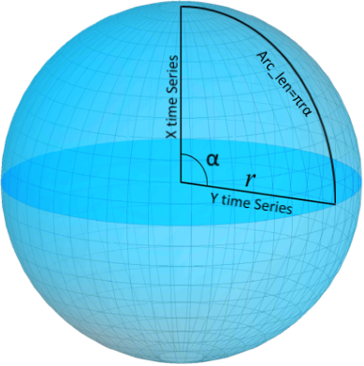 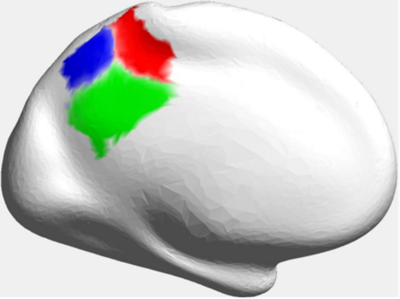 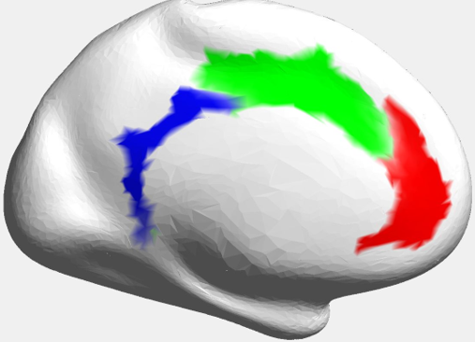 Figure 1: distance between Figure2: modulated mode map Figure 3: modulated mode map

two time-series X and Y for precuneus: each subject subdivided for cingulate: each subject subdivided

into 3 clusters separately, image hue into 3 clusters separately, image hue

reflects fraction of the 40 subjects reflects the fraction of the 40 subjects

that agree with most common label. that agree with most common label.

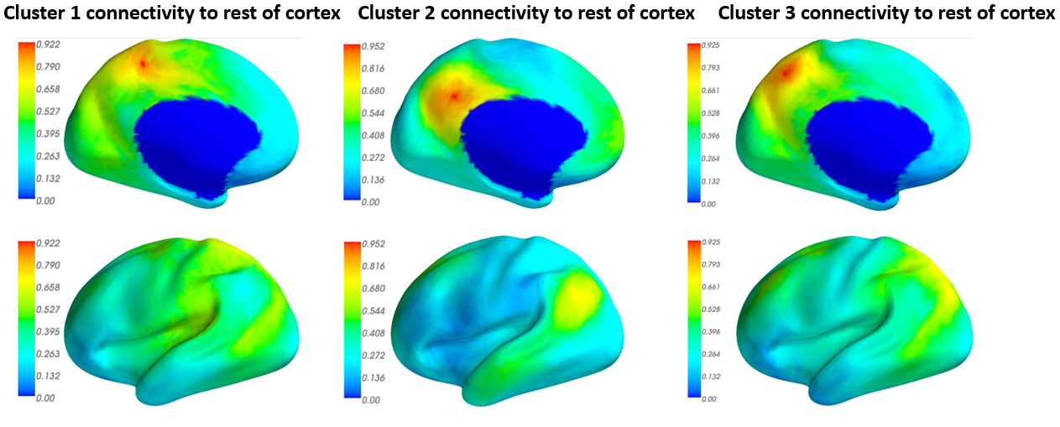

Figure 4: Functional connectivity of the precuneus to the rest of the cortex measured by correlation

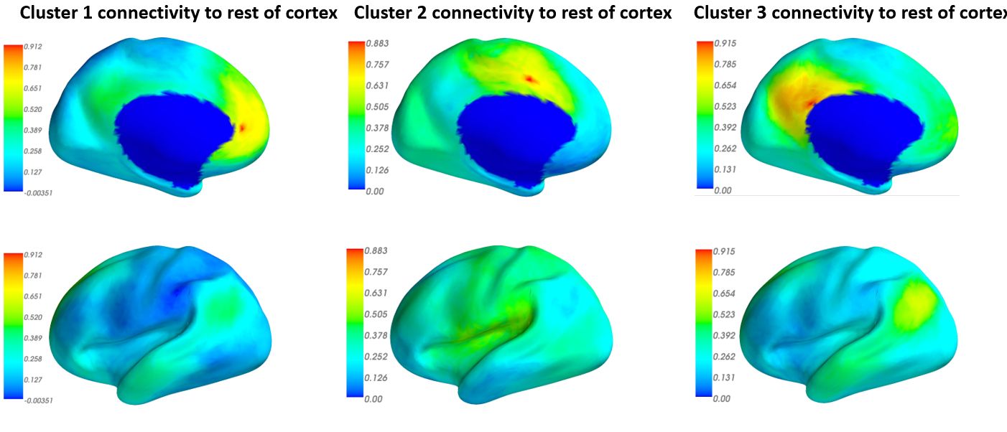

Figure 5: Functional connectivity of cingulate to the rest of the cortex measured by correlation

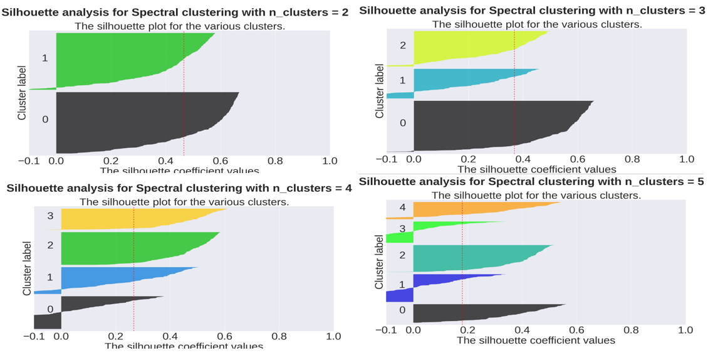

Figure 6: Silhouette Score for precuneus for different number of cluster

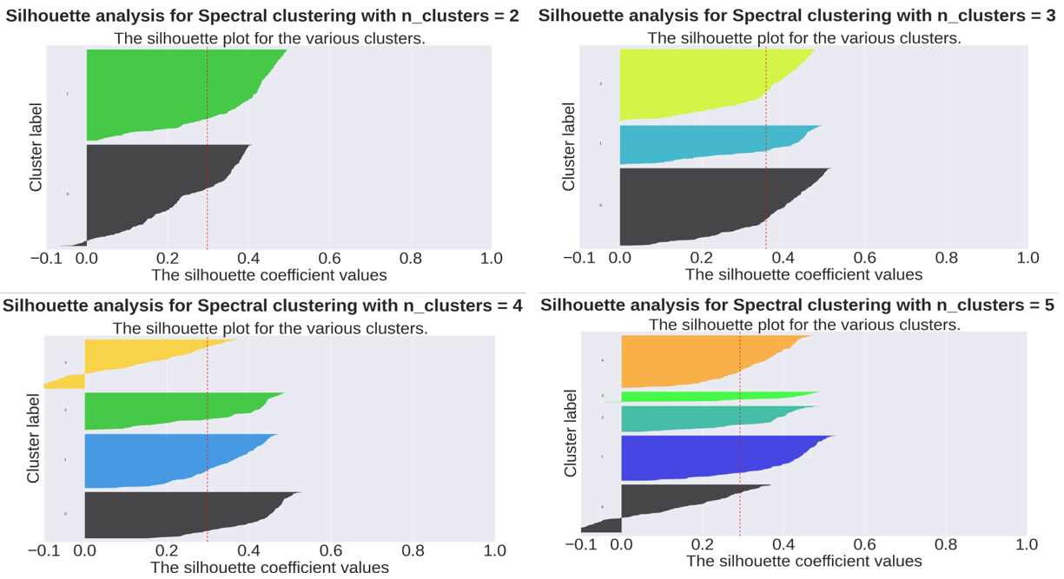

Figure 7: Silhouette Score for cingulate for different number of cluster

**Acknowledgement**

Data were provided by the Human Connectome Project, WU-Minn Consortium (Principal Investigators: David Van Essen and Kamil Ugurbil; 1U54MH091657) funded by the 16 NIH Institutes and Centers that support the NIH Blueprint for Neuroscience Research; and by the McDonnell Center for Systems Neuroscience at Washington University.

**References:**

1. Peter J. Rousseeuw (1987). “Silhouettes: A Graphical Aid to the Interpretation and Validation of Cluster Analysis”. Computational and Applied Mathematics 20: 53-65.
2. David C. Van Essen, Stephen M. Smith, Deanna M. Barch, Timothy E.J. Behrens, Essa Yacoub, Kamil Ugurbil, for the WU-Minn HCP Consortium. (2013). The WU-Minn Human Connectome Project: An overview. NeuroImage 80(2013):62-79.
3. Bhushan C, Chong M, Choi S, Joshi AA, Haldar JP, et al. (2016) Temporal Non-Local Means Filtering Reveals Real-Time Whole-Brain Cortical Interactions in Resting fMRI. PLoS ONE 11(7).
4. Margulies, Daniel S., Justin L. Vincent, Clare Kelly, Gabriele Lohmann, Lucina Q. Uddin, Bharat B. Biswal, Arno Villringer, F. Xavier Castellanos, Michael P. Milham, and Michael Petrides. "Precuneus shares intrinsic functional architecture in humans and monkeys." Proceedings of the National Academy of Sciences 106, no. 47 (2009): 20069-20074.